Все о дизайне интерьеров, строительстве и архитектуре в журналах ИД «Красивые дома пресс»
​​​​​​​Тел: +7 495 730 5592
​​​​​​​Email: info@houses.ru

Architecture, interior design, construction and all about your home in the "Beautiful Houses Press" Publishing House magazines
Tel: +7 495 730 5592
Email: info@houses.ru
@id_beautiful_houses

Newest issues of the magazines "Pool and Sauna" №3 (112)' 2020 and "Beautiful Houses" №3 (202) '2020 are now available both in stores and online! You can read free full online versions on our website in your computer, tablet or smartphone with Internet access.

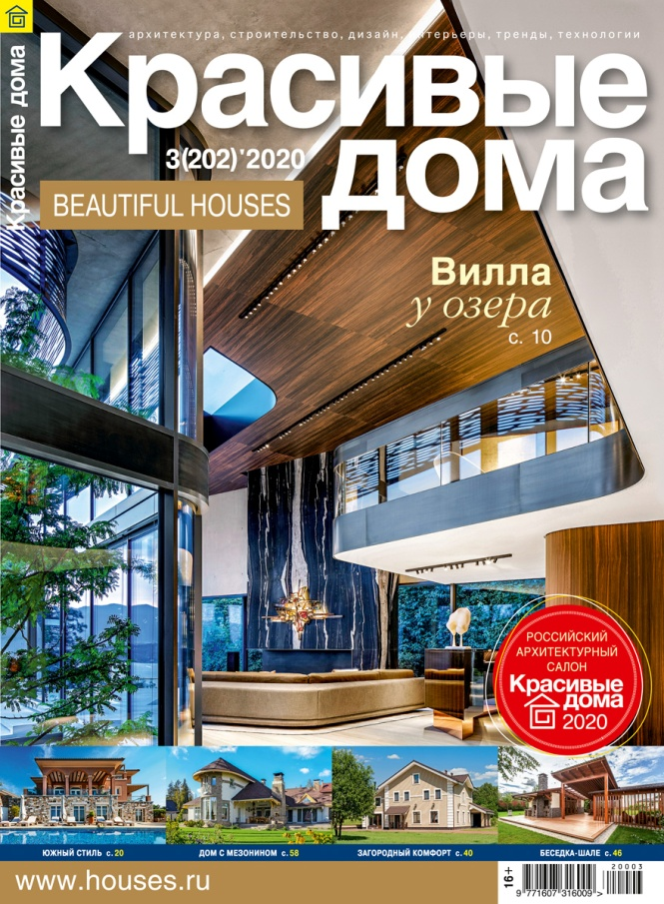

​​​​​​​The issue contents:
"Beautiful houses" Magazine №3 / 202 - 2020

• Villa by the lake: an exclusive project from the Saota company, realized in Switzerland;

• Southern style: a respectable residence on the Mediterranean coast.
Gazebo-chalet: multifunctional space for relaxation with Alpine charm;

• Countryside comfort: a manor complex with a swimming pool and a tennis court;

• From scratch: a modern cottage with unique interiors and details

The issue contents:
«Pool and Sauna» Magazine №3 / 112 - 2020

• Under the dome: lightweight sliding pavilions for outdoor pools;

• Heat energy: highlight features of sauna and steam rooms equipped with infrared emitters;

Magic of water and fire: a modern fireplace as a wellness space element;

• Spa at the Maranello Residence: swimming pool and thermal area with hammam and aroma sauna;

• Sauna assistants: useful accessories for use in a sauna and a steam room;

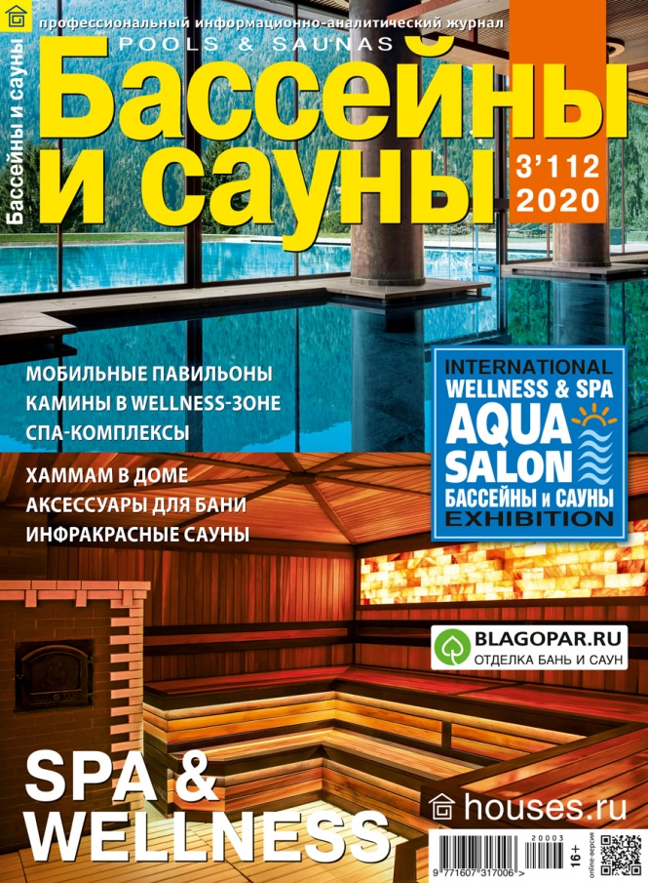

We in Beautiful Houses have much more to show and tell you! To be in, just follow us in your favorite social net

